Game Design Document

Fill up the following document

1. Write the title of your project.

Space Invaders

1. What is the goal of the game?

Kill The Aliens And don’t get hit by the bullets from the alien ships

1. Write a brief story of your game.

The whole world is being attacked by aliens so the earth develops

A specialized space ship that was designed to fight the aliens but the plan did not very well the aliens destroyed the place where the rockets were supposed to launch off but one spaceship managed

To escape and is waiting for back up and is facing a whole army of alienspace ships.

1. Which are the playing characters of this game?

* Playing characters are the ones who respond to the user based on the input from the user.
* Cars, monkeys, dinos, wizards, etc., are the playing characters in the game.

|  |  |  |
| --- | --- | --- |
| Number | Character Name | What can this character do? |
| 1 | Fighter Space Ship | Controlled by character and shoots bullets |
| 2 | A Basic Alienship | Shoots bullets at the player |
| 3 | A armoured Alienship | Is Faster Than the basic alien ship and shoots faster |
| 4 | A Strong Alienship | Is twice as strong and fast as armoured alienship |
| 5 | A Big Alienship | Shoots bigger bullets and and more health points |
| 6 | The UFO | Spawn rarely and give one health point |
| 7 | The Boss | Once You kill a certain amount of alienships he spawns |
| 8 |  |  |

1. Which are the Non-Playing Characters of this game?

* Non-Playing characters are the ones that don't have an action or behavior when the user interacts with the game.
* Hurdles, stones, bananas, coins, etc., are non-playing characters in the game.

|  |  |  |  |
| --- | --- | --- | --- |
| Number | Character Name | | What can this character do? |
| 1 | Bullets | | Shoot |
| 2 | Power-Ups | | Boost the player |
| 3 |  |
| 4 |  | |  |
| 5 |  | |  |
| 6 |  | |  |
| 7 |  | |  |
| 8 |  | |  |

Draw your imagination of this game. What does this game look like?

* Draw the game either on your computer or on paper.
* Add images of the game scenes to show each of the playing and non-playing characters at least once.

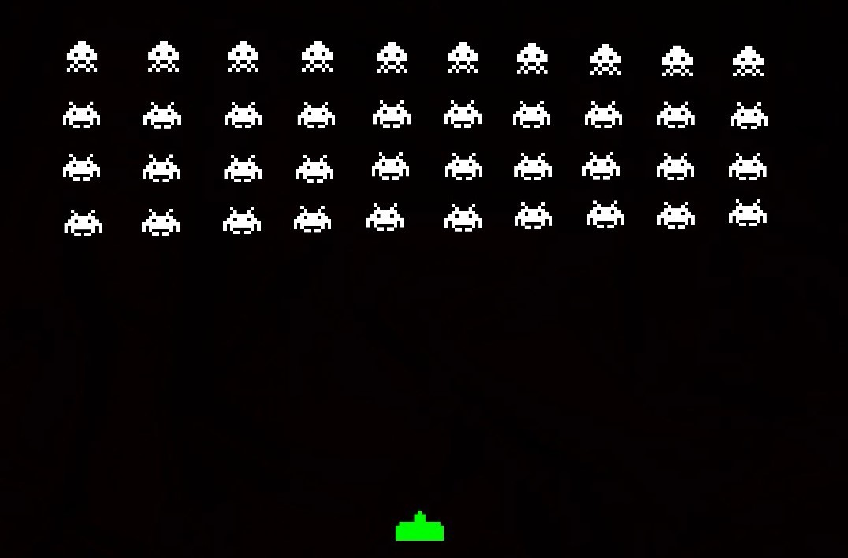

How do you plan to make your game engaging?

Harder levels each Time

Add power ups